**Install Appium**

1. **Install Xcode**

Go to App Store, then search Xcode, download it.

Install Xcode: double click xcode_5.1.1.dmg open it. Then drag it to Applications in pop-up window.

1. **Install IOS SDK**

Go to official website of android studio, download it.

Install SDK: double click android-studio-ide-141.1890965-mac.dmg open it. Then drag it to Applications in pop-up window.

1. **Install Appium**

Go to official website of Appium, then click Download Appium button, will redirect to below download list, select appium version that need to install (see screenshot)

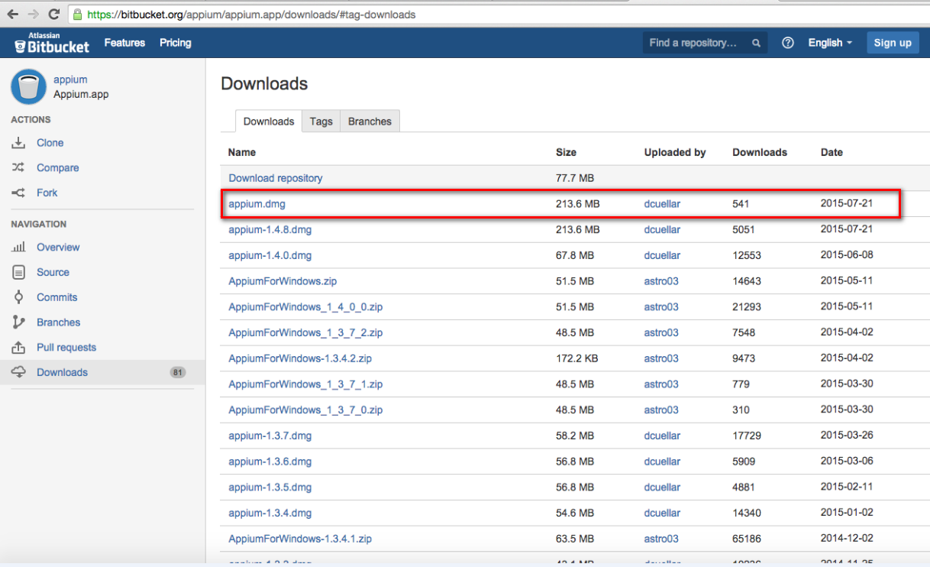

Install Appium: double click appium.dmg open it. Then drag it to Applications in pop-up window.

1. **Install Appium client**
   1. Install pyenv

Execute below command on terminal

“ brew install pyenv”

4.2 install python

Execute below command on terminal

pyenv install 2.7.9

4.3 install client for python

Execute below command on terminal

pip install Appium-Python-Client

4.4 install python module

Execute below command on terminal

pip install tap.py

pip install colour_runner

1. **install installer**

Execute below command on terminal

brew install ideviceinstaller

1. **install webkit proxy**

Execute below command on terminal

brew install ios-webkit-debug-proxy

1. **install underscore**

Execute below command on terminal

npm -g install underscore

1. **npm command**

if npm command is unavailable, need to install node.js, URL is <https://nodejs.org/>

1. **Chromedriver**

Put Chromedriver version 2.14or2.15 in below path

/Applications/Appium.app/Contents/Resources/node_modules/appium/build/chromedriver/mac

1. **Setting JAVA_HOME and ANDROID_HOME**

In .profile of  user's home directory(see screenshot)

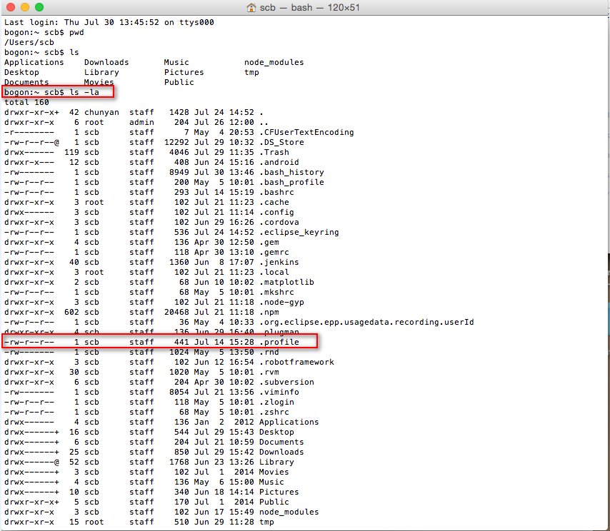

Setting JAVA_HOME and ANDROID_HOME

export ANDROID_HOME="/Users/scb/Downloads/adt-bundle-mac-x86_64- 20130219/sdk"

export JAVA_HOME="/System/Library/Java/JavaVirtualMachines/1.6.0.jdk/Contents/Home"

export PATH="$PATH:$HOME/.rvm/bin:$ANDROID_HOME:$ANDROID_HOME/platform-tools:$JAVA_HOME:$ANT_HOME/bin"

1. **Check the environment whether is available or not**

open Appium client , click Doctor icon(see screenshot),if which one is unavailable ,the Doctor will remind you.

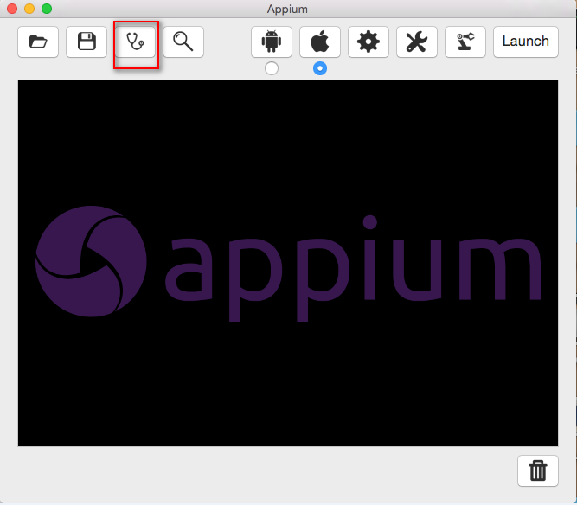

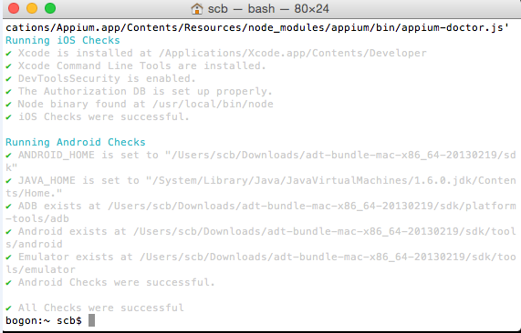

1. **Install Xcode Command Line Tools**

In addition, need to install Xcode Command Line Tools, if still don’t install, don’t worry, the Doctor of Appium will remind you, then according to the prompt install it.

**Install & run ride**

**The first step: download & install wxPython**

wxPython is the need for RIDE, note that must be install unicode version, click on the download list, select wxPython2.8-osx-unicode-2.8.12.1-universal-py2.7.dmg, download & install.

**Second step: download & install RobotFramework**

There are two ways for install RobotFramework, the one is used pip command, command is: “pip install robotframework” .another one is used setup.py, download .Zip folder in official website, execute command “python setup.py install”

**Third step: download & install RIDE**

Download RIDE in Git,<https://github.com/robotframework/RIDE/releases/>,

Then execute command “pip install robotframework-ride”. or download the source code then unzip, execute command “python ride_postinstall.py install” .don’t pop-up error message means install successful.

**The last step: run RIDE**

Open terminal in Mac OS X, then input command “ ./ride.py “ & Enter. If no issue, will open the RIDE. If display this error “python should be executed in 32-bit mode to support wxPython on mac. Check BUILD.rest for details” because the OS　X is 64-bit,but the Python need to support wxPython in 32-bit,the solution is edit ride.py.

“Export VERSIONER_PYTHON_PREFER_32_BIT=yes

/usr/local/bin/ride.py “

Then run command “./ride.py” in terminal, the RIDE will open successful

**Automation test in ios BMW**

1. In SCBLibrary folder, setup _setup_wrapper.py file, see screenshot

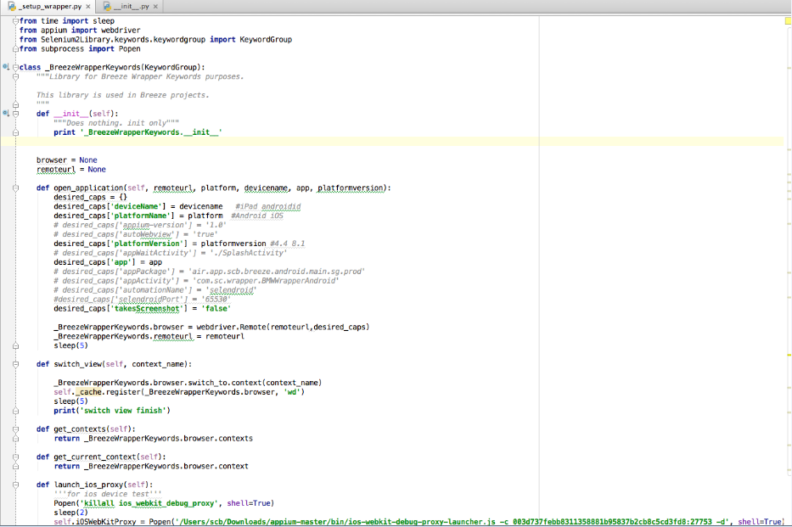

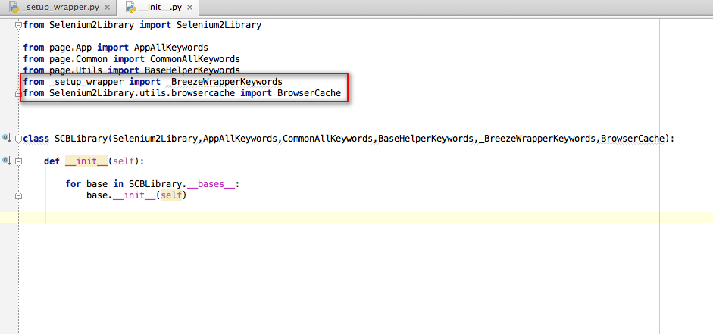

1. **setup test case in RIDE, see screenshot**

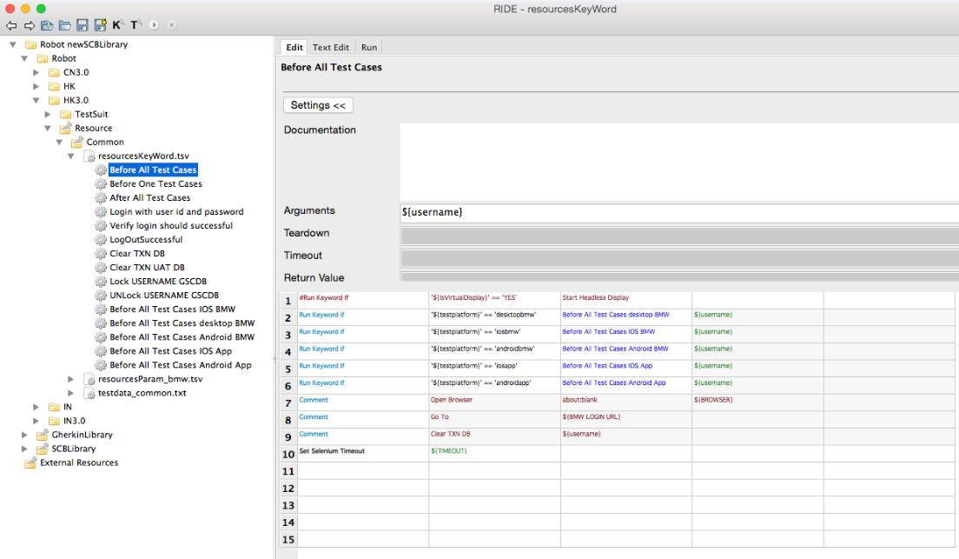

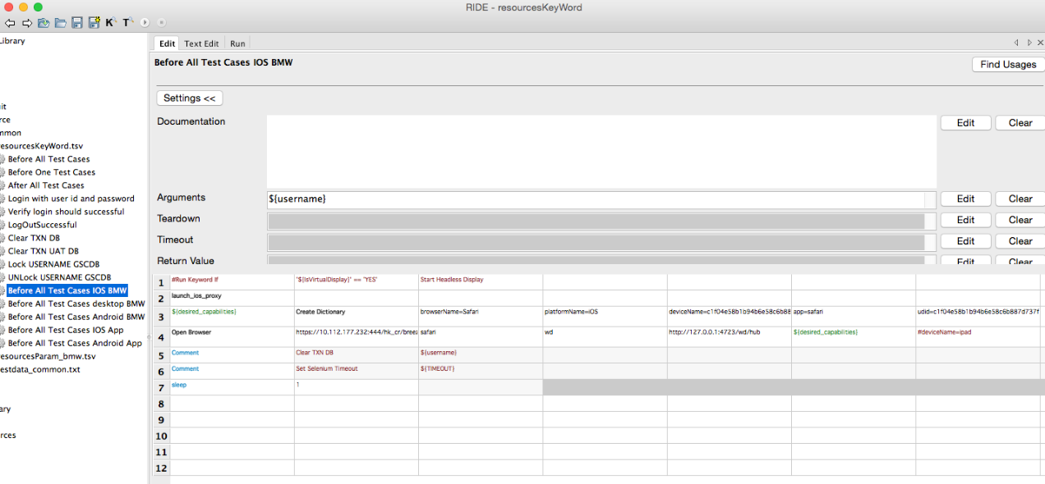

1. **run test case with safari, should be download SafariLauncher.app** <https://github.com/appium/appium/issues/1083> ,then replaced SafariLauncher.app in /Applications/Appium.app/Contents/Resources/node_modules/appium/build/SafariLauncher/SafariLauncher.zip
2. Safari browser setting: Settings > Safari > Advanced > Web Inspector = ON
3. Appium setting(see screenshot)

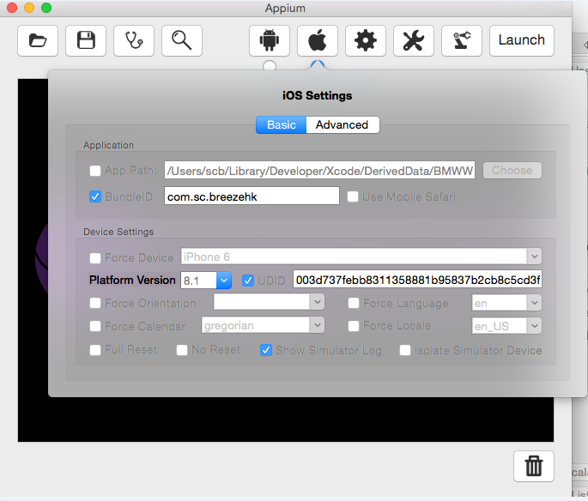

BundleID is bundleID is project bundle identify id,open SafariLaunch with Xcode,find it BundleID

UDID:xcode->windows->devices->device information->identifier

**Automation test in ios Wrapper**

1. test case(see screenshot)

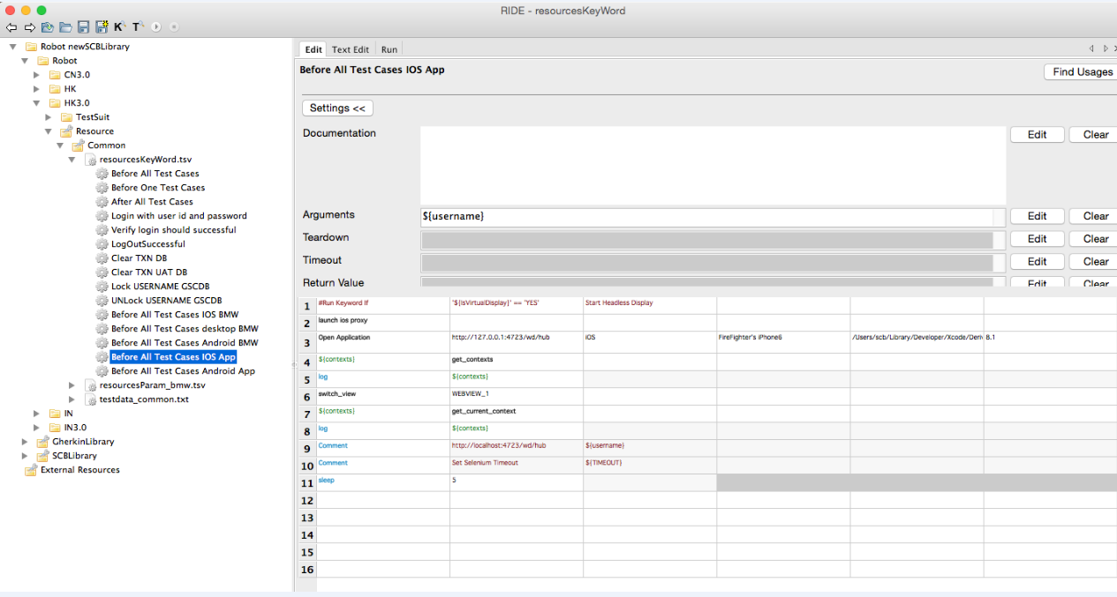

1. Appium setting(see screenshot)

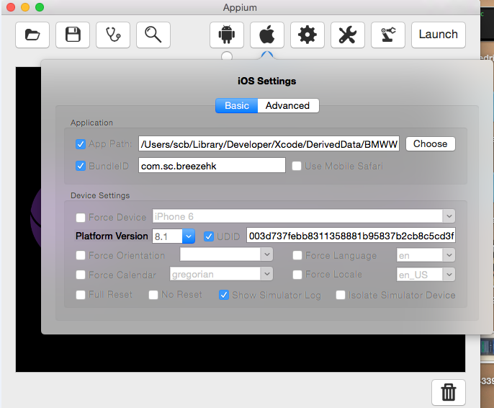

App Path:/Users/scb/Library/Developer/Xcode/DerivedData/BMWWRapper- dyrctnwuvxygpsghtduvpkbdxqjm/Build/Products/Debug-iphoneos/BMWWRapper.app

BundleID：Wrapper bundleID

UDID: xcode->windows->devices->device information->identifier

1. Connect to real device, should be Launch Appium first.

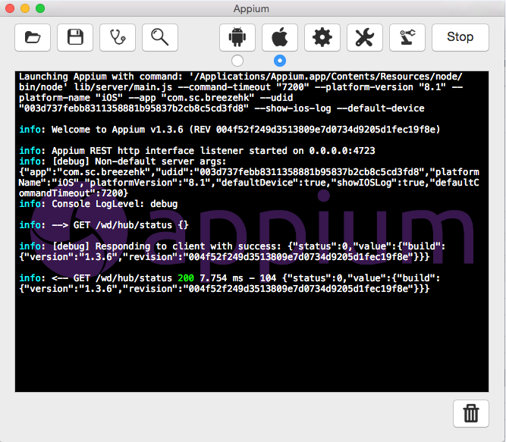

**Automation test in Android BMW &Wrapper**

1. Setup new test case in RIDE, see screenshot

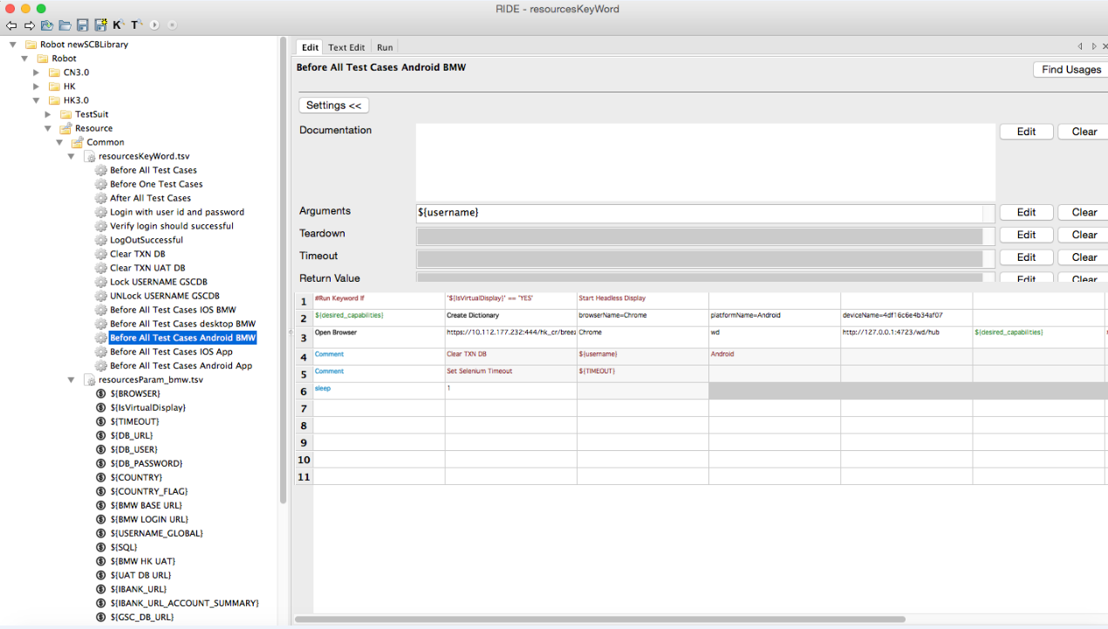

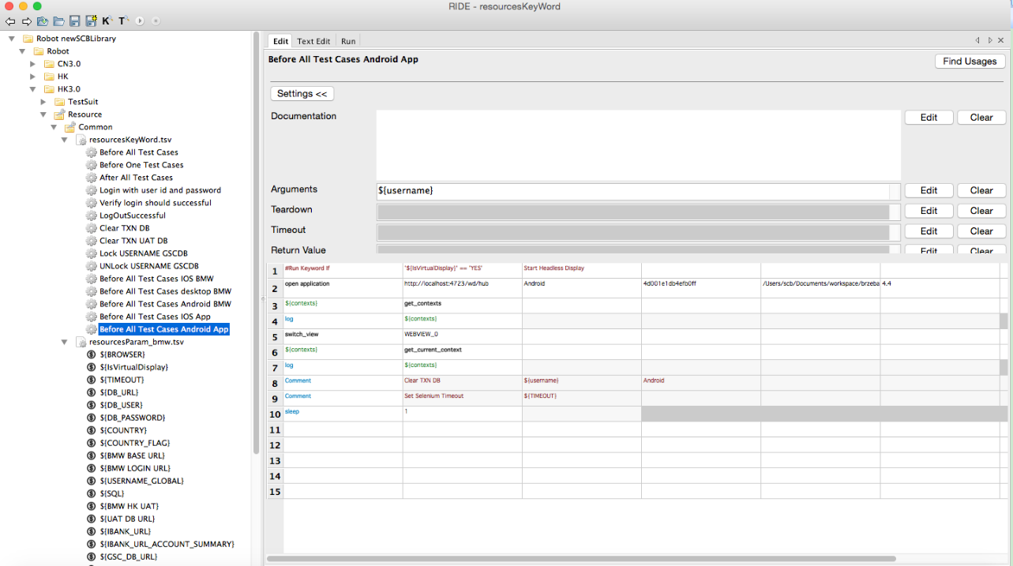

1. Appium setting of Android BMW, see screenshot

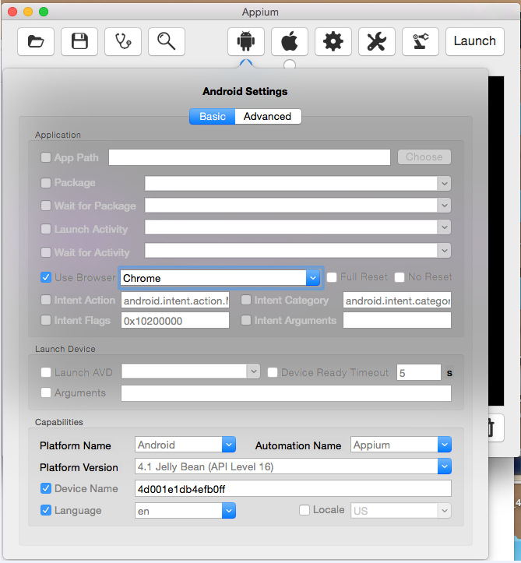

1. Appium setting of Android wrapper, see screenshot

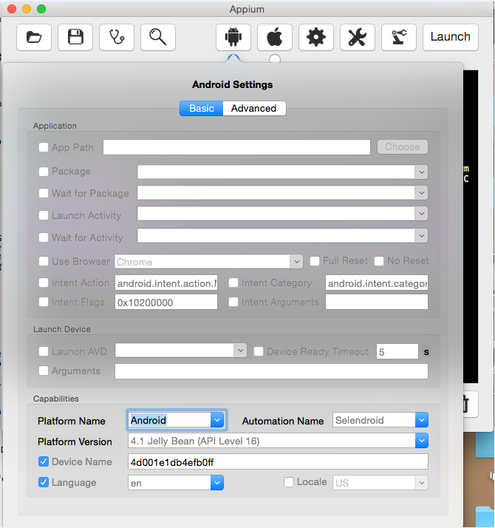

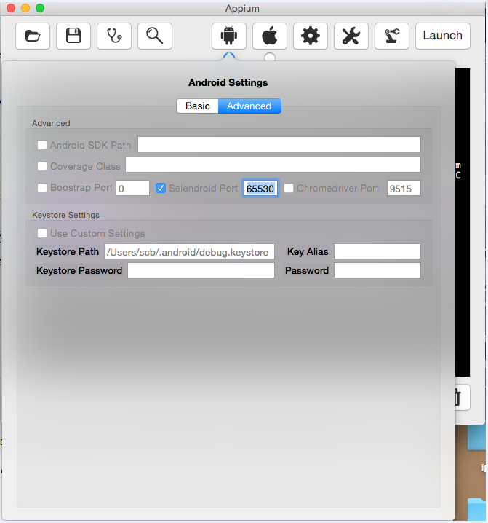

1. Check whether real device is connect successful or not

